

# AUGUST- 2023

**Programme : B.E / B. Tech**

**Course Code : CSA1190**

**Course Name** **: OBJECT ORIENTED ANALYSIS AND DESIGN**

**Date : 26-08-2023**

OOAD PRACTICAL DAY 2

**EXP 11: CONFERENCE MANAGEMENT SYSTEM**

**AIM:** To draw UML diagrams for conference managment system.

**USE CASE :**

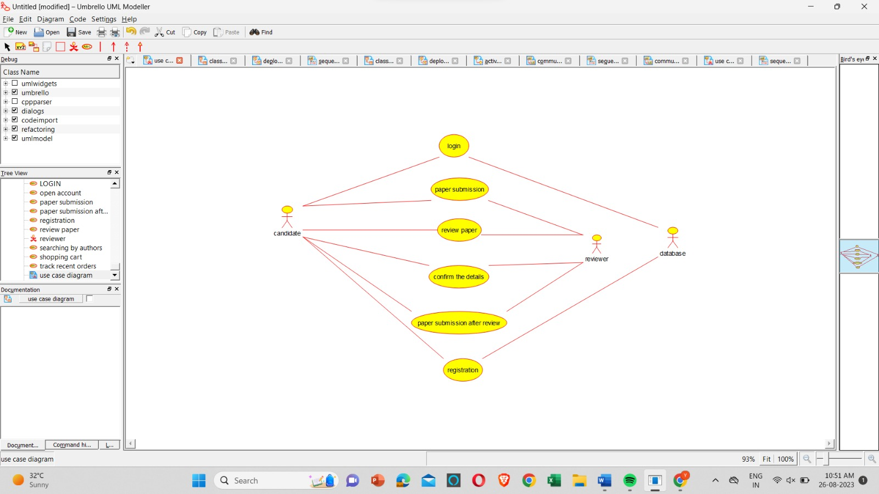

**CLASS DIAGRAM :**

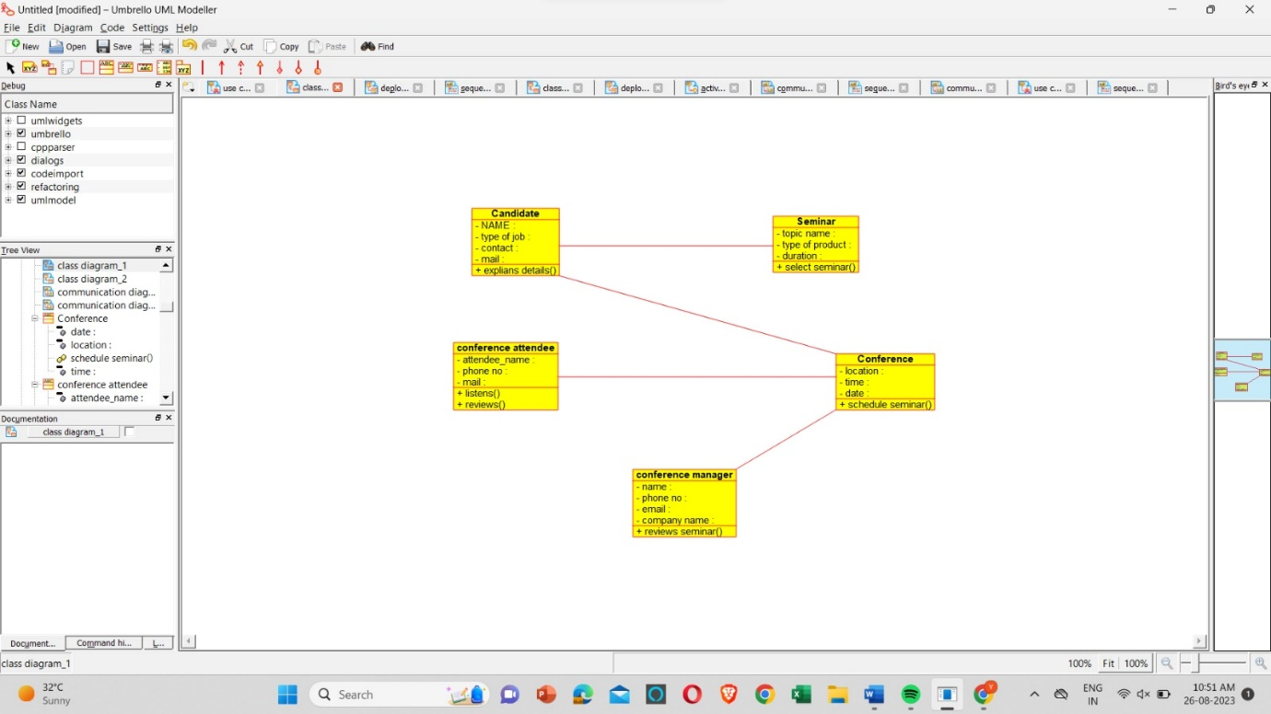

**DEPLOYMENT :**

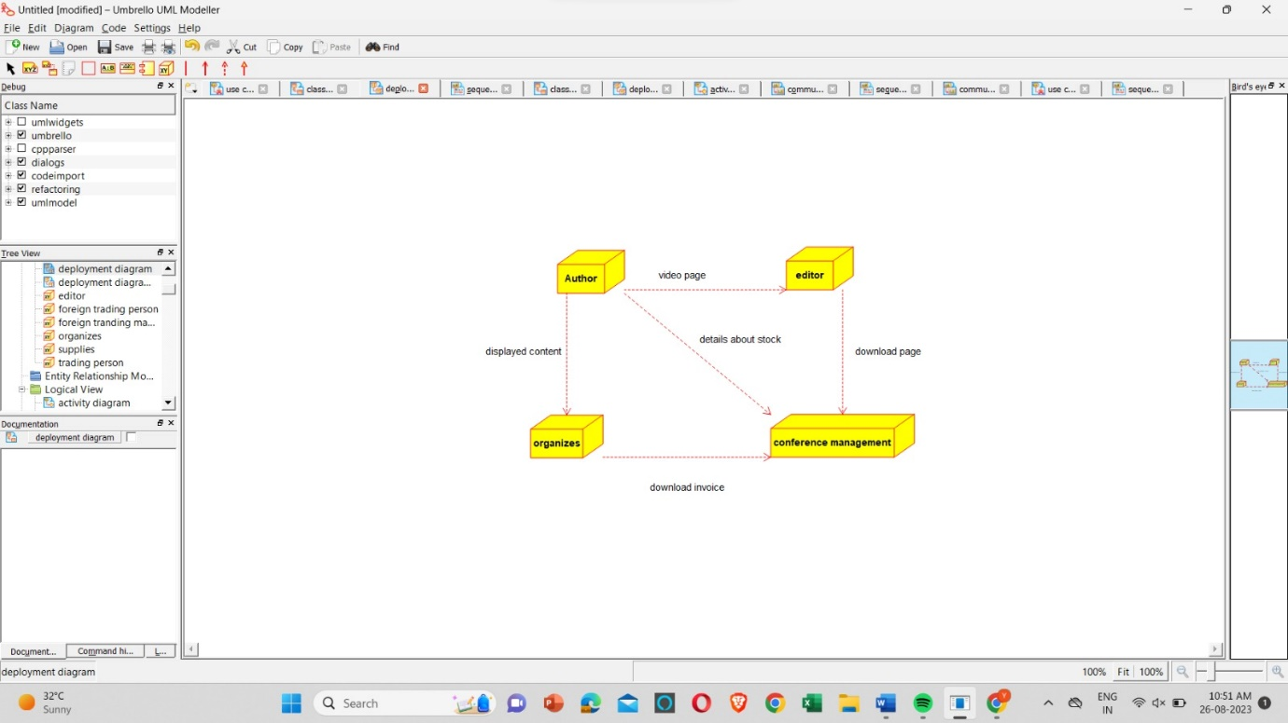

**RESULT** : Program was Executed Successfully using Umbrello**.**

**EXP 12 : FOREIGN TRADING SYSTEM**

**AIM :** To draw the UML diagrams for foreign trading system using umbrello.

**SEQUENCE :**

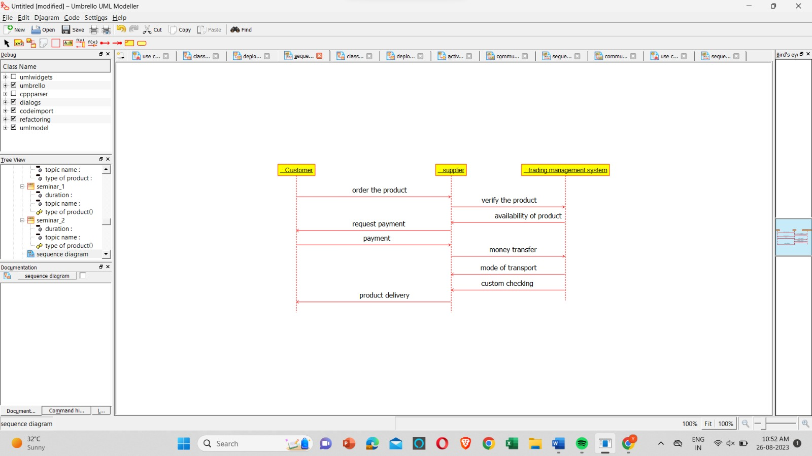

**CLASS DIAGRAM :**

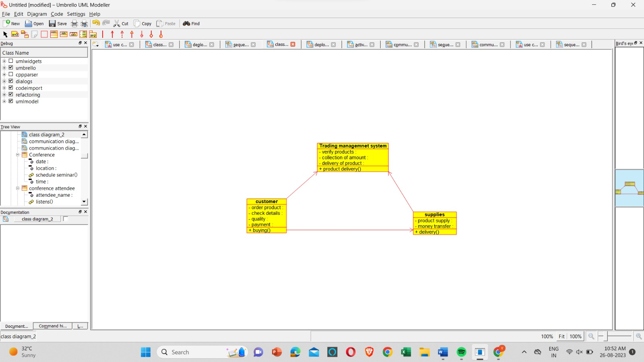

**DEPLOYMENT:**

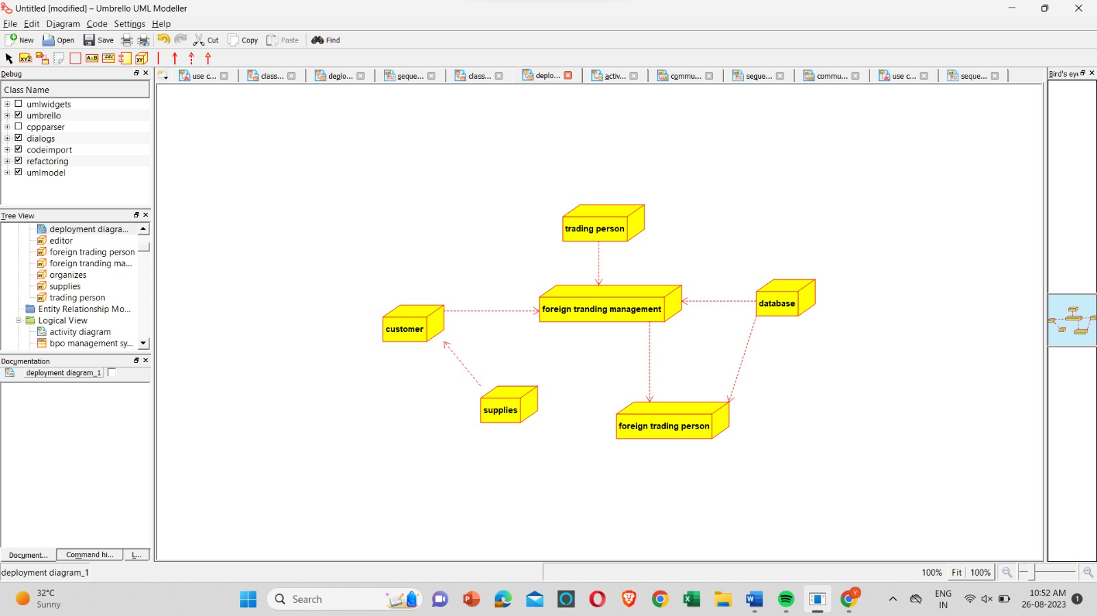

**RESULT** : Program was Executed Successfully using Umbrello**.**

**EXP 13 :** **BPO Management System**

**AIM :** To draw the UML diagrams for Bpo management system using umbrello.

**AVTIVITY :**

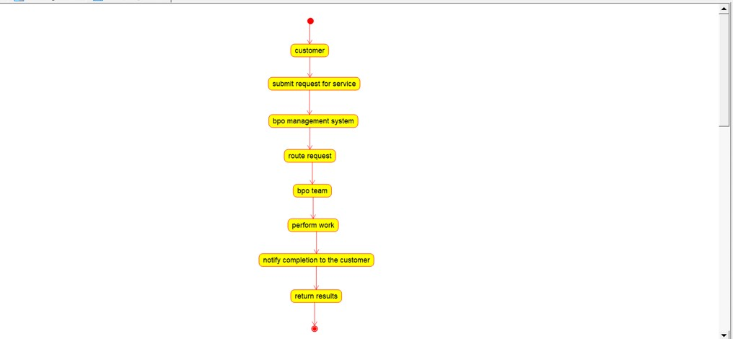

**COMMUNICATION:**

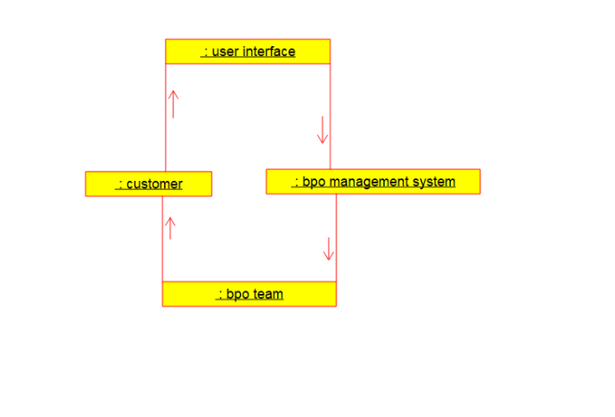

**SEQUENCE:**

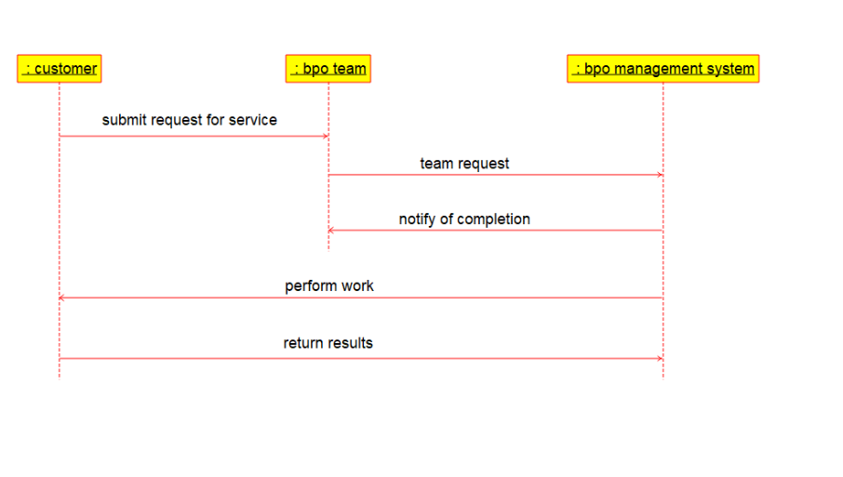

**RESULT** : Program was Executed Successfully using Umbrello**.**

**EXP 14 :** **E-Commerce Registration System**

**AIM :** To draw UML diagram for E-Commerce Registration using umbrello.

**COMMUNICATION :**

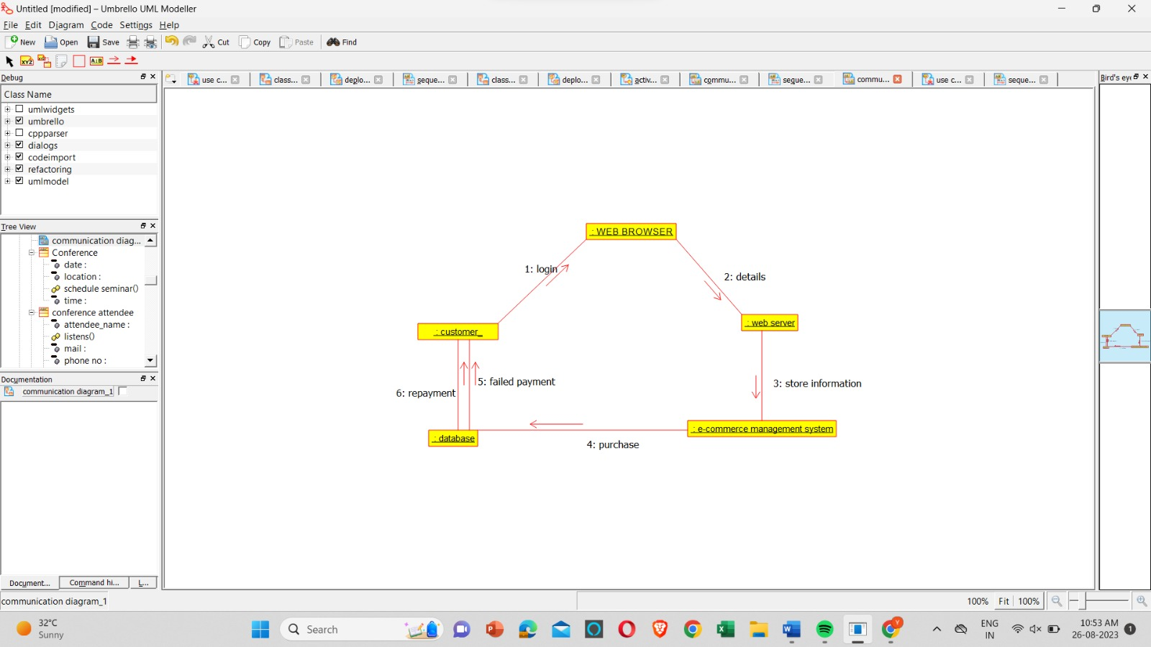

**USECASE :**

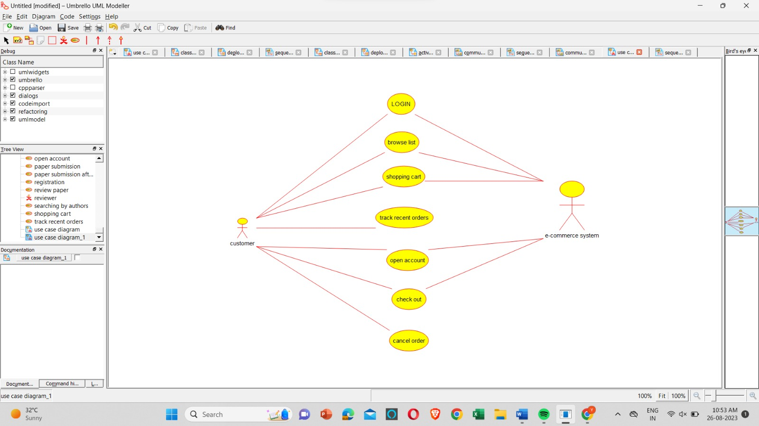

**SEQUENCE:**

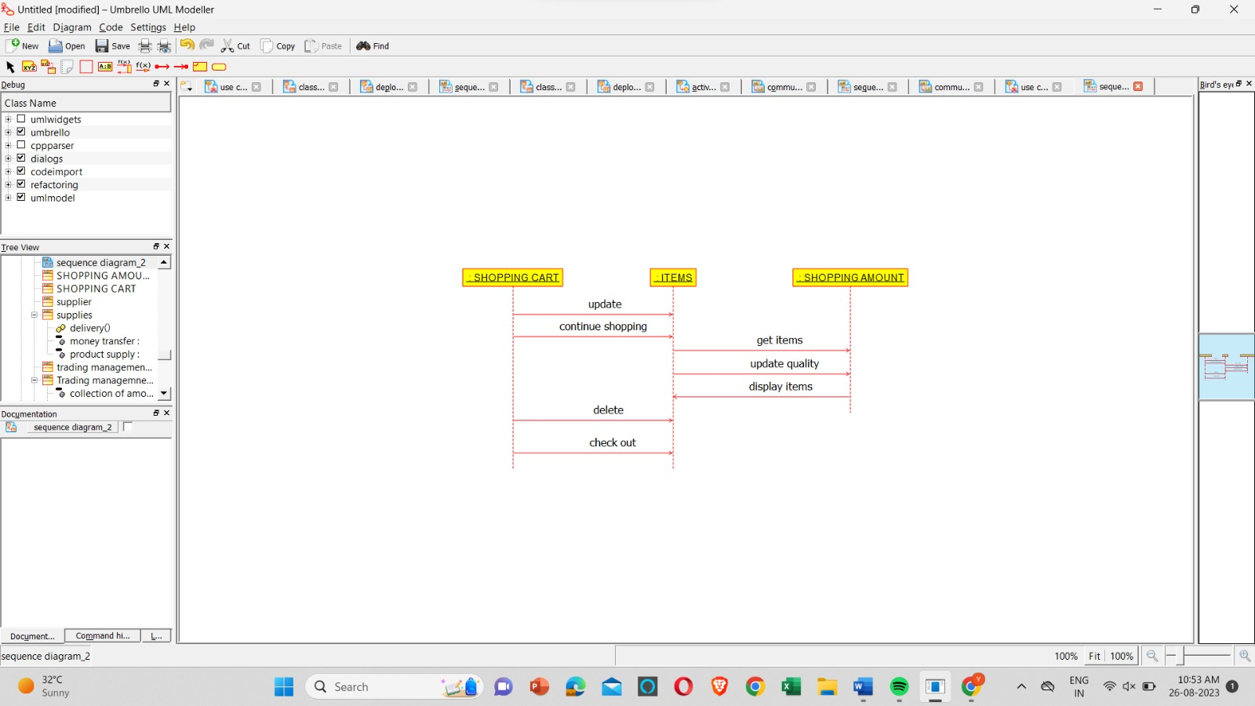

**RESULT** : Program was Executed Successfully using Umbrello**.**

**EXP 15 : BLOOD BANK REGISTRATION SYSTEM**

**AIM** : To draw the uml diagram for blood banking registration using umbrello.

**COLLABORATION:**

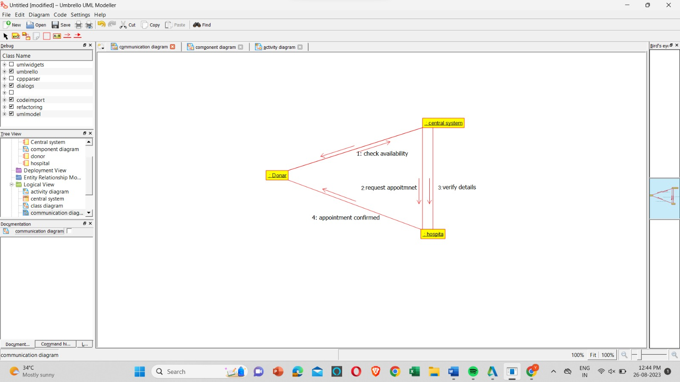

**COMPONENT :**

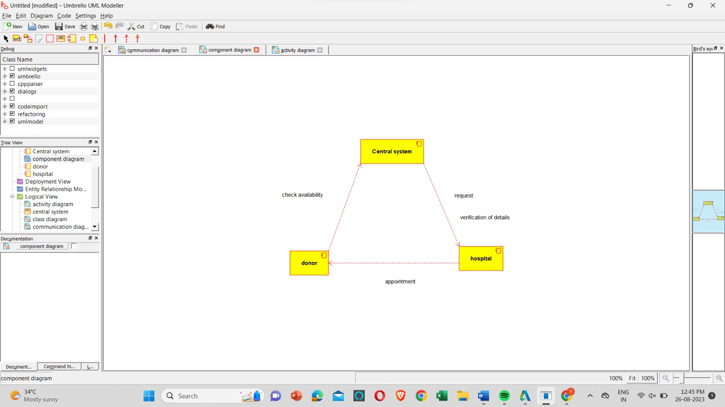

**ACTIVITY :**

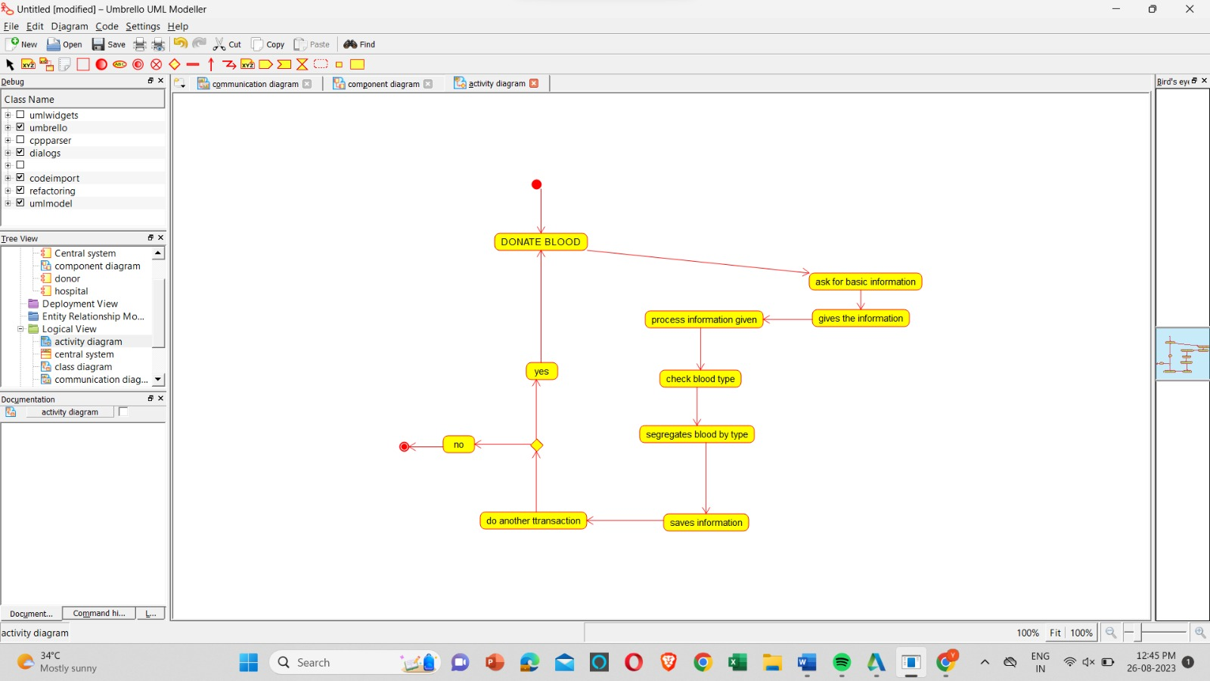

**RESULT** : Program was Executed Successfully using Umbrello**.**

**EXP 16 : ONLINE INTERNSHIP REGISTRATION**

**AIM :**  To draw the uml diagram for online internship registration using umbrello.

**COMMUNICATION:**

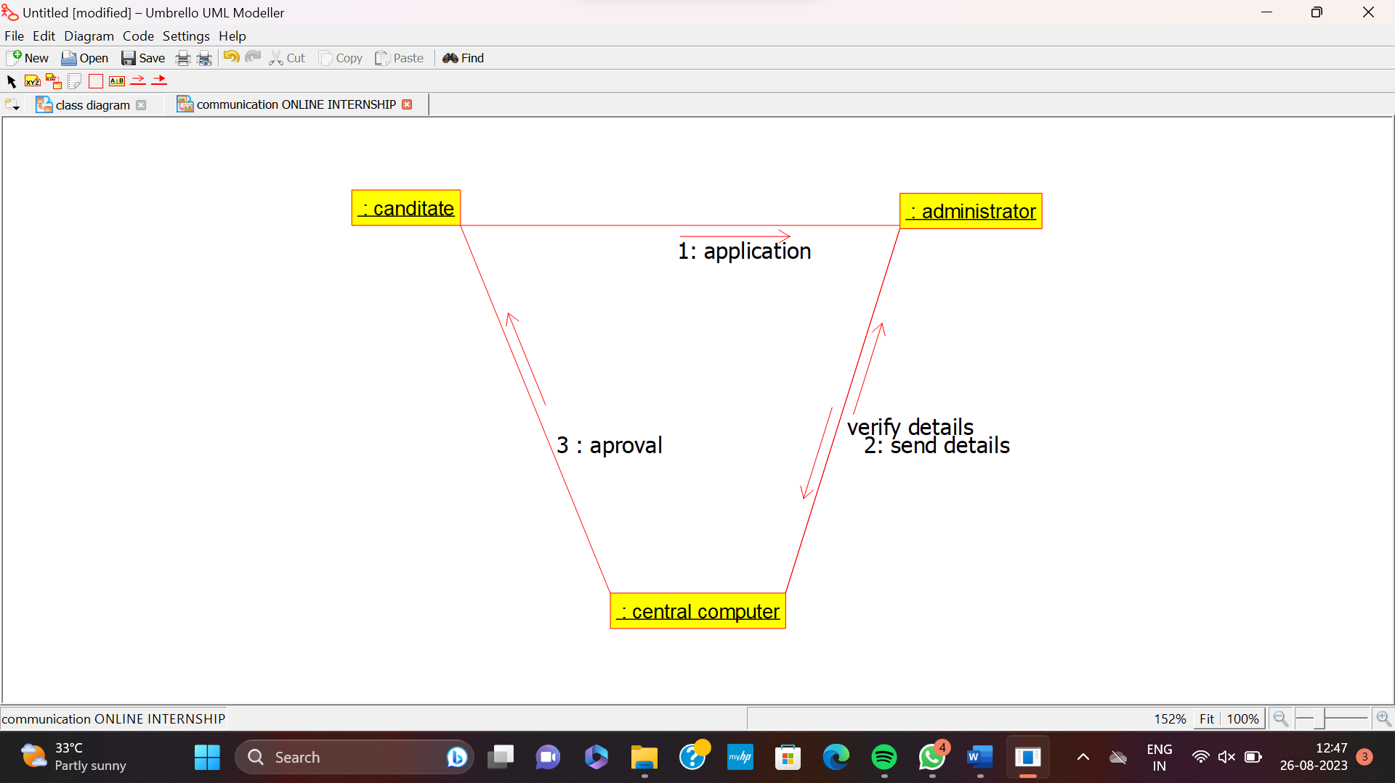

**SEQUENCE :**

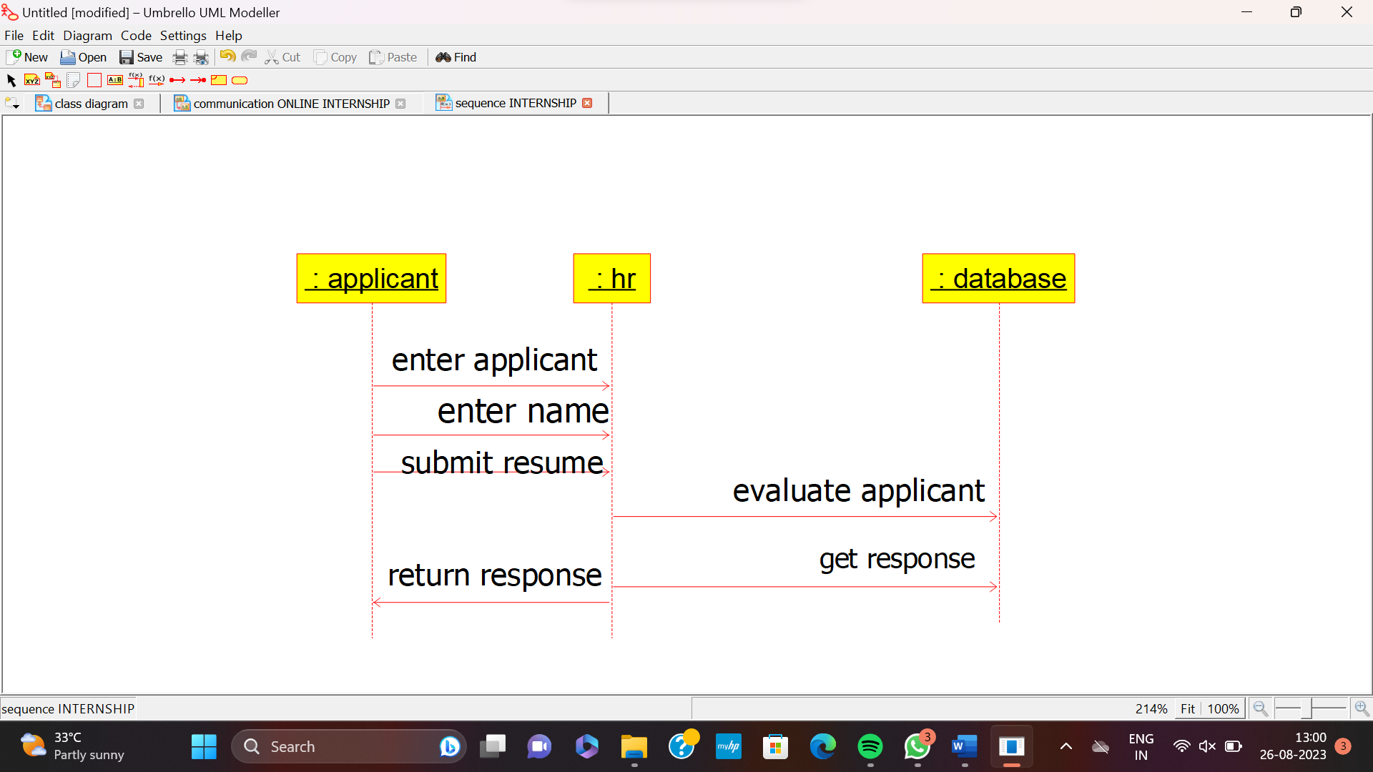

**COMPONENT :**

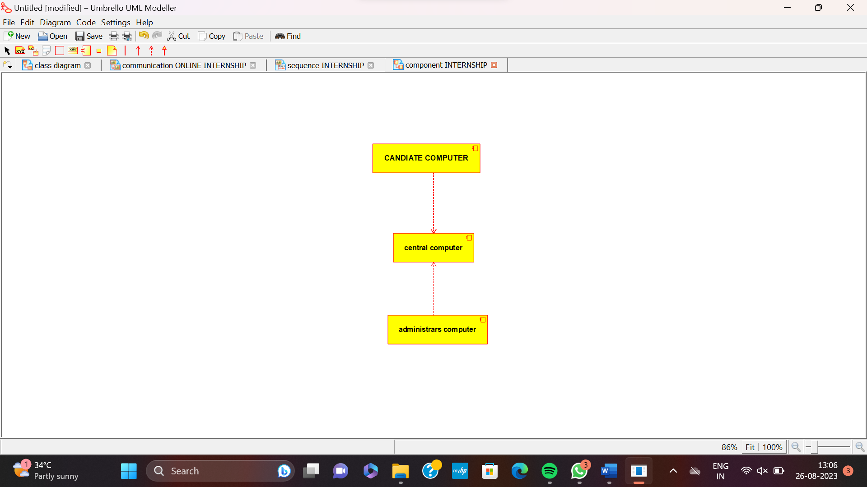

**RESULT** : Program was Executed Successfully using Umbrello**.**

**EXP 17 : VECHICLE REGISTRATION**

**AIM : :**  To draw the uml diagram for vehicle registration using umbrello.

**SEQUENCE :**

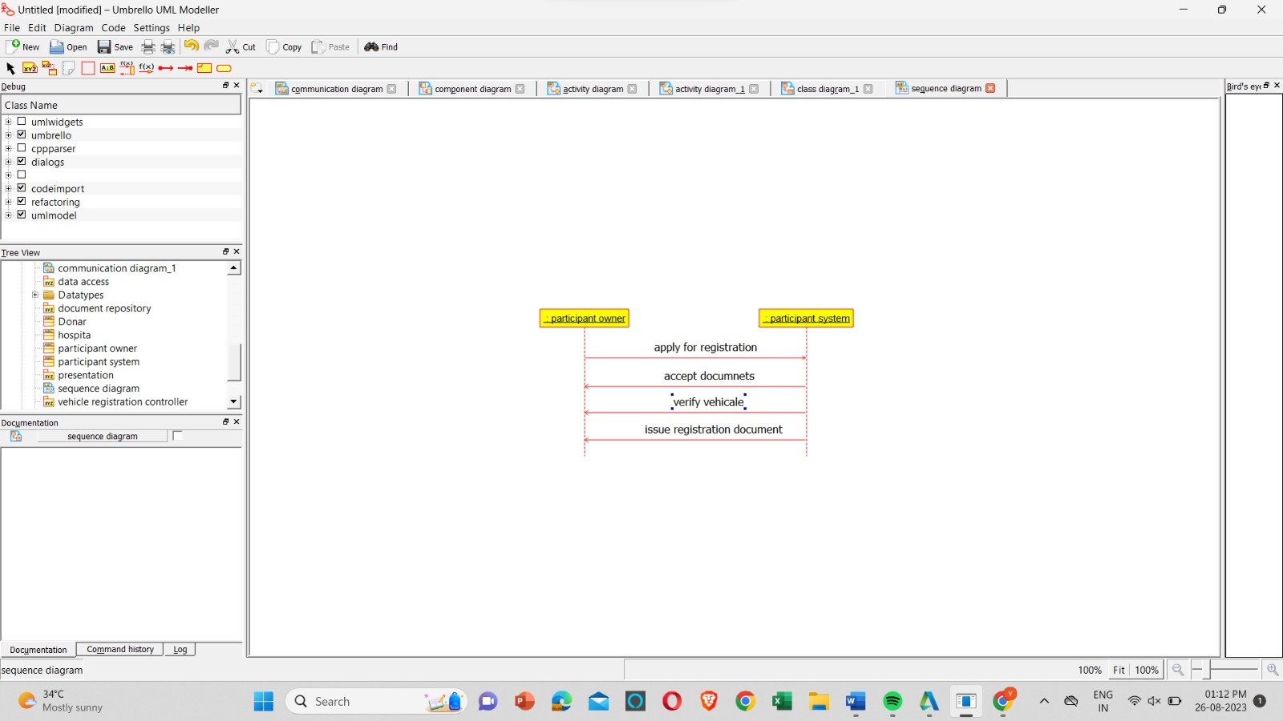

**ACTIVITY :**

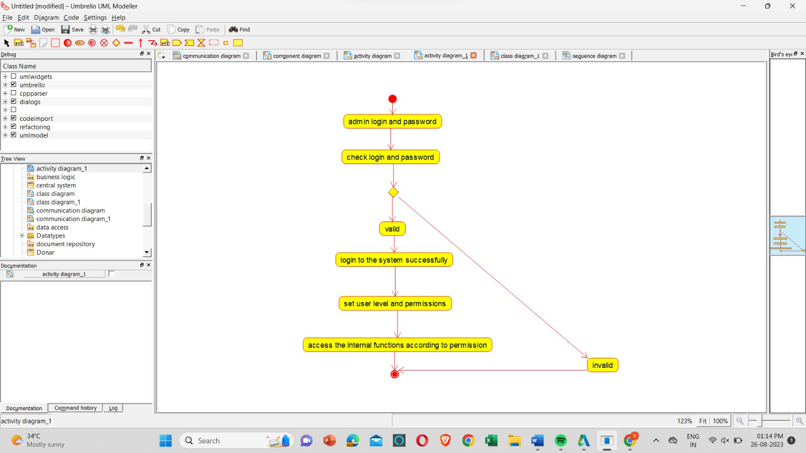

**PACKAGE :**

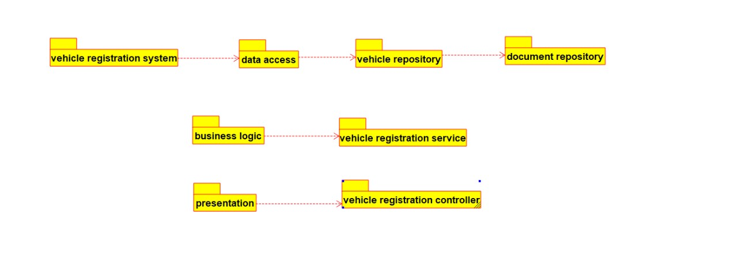

**RESULT** : Program was Executed Successfully using Umbrello**.**

**EXP 18 : FOOD ORDERING SYSTEM**

**AIM :** To draw the UML diagrams for food ordering system using umbrello.

**USE CASE :**

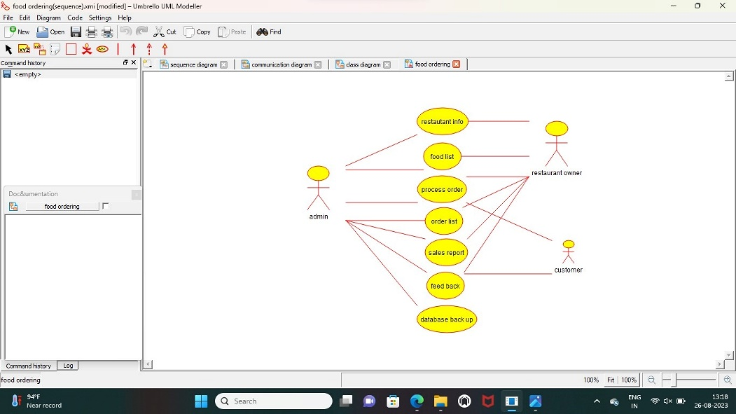

**SEQUENCE DAIGRAM :**

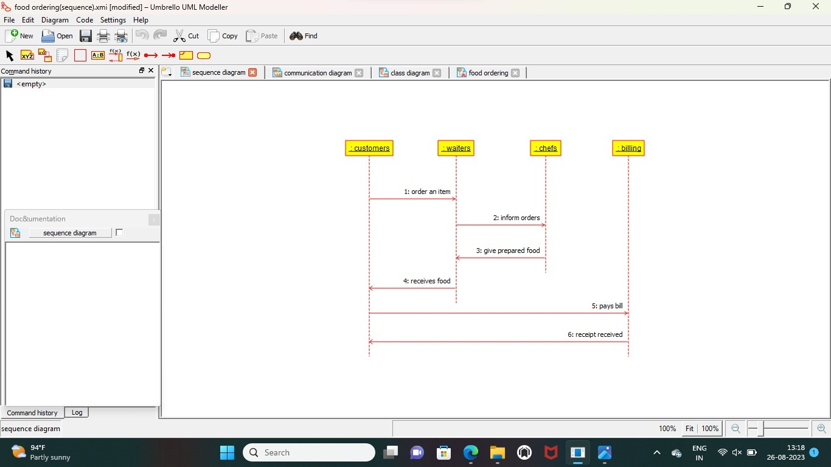

**COLLABRATION :**

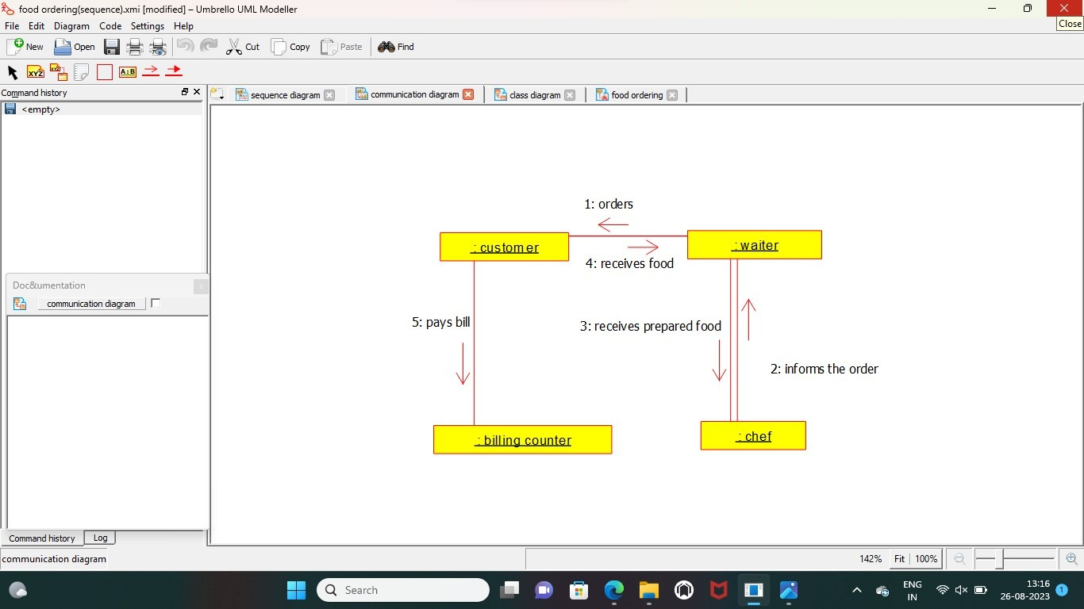

**RESULT :** Program was Executed Successfully using Umbrello.

**EXP 19:HOME SERVICE SYSTEM**

**AIM :** To draw the UML diagrams for food ordering system using umbrello.

USE CASE

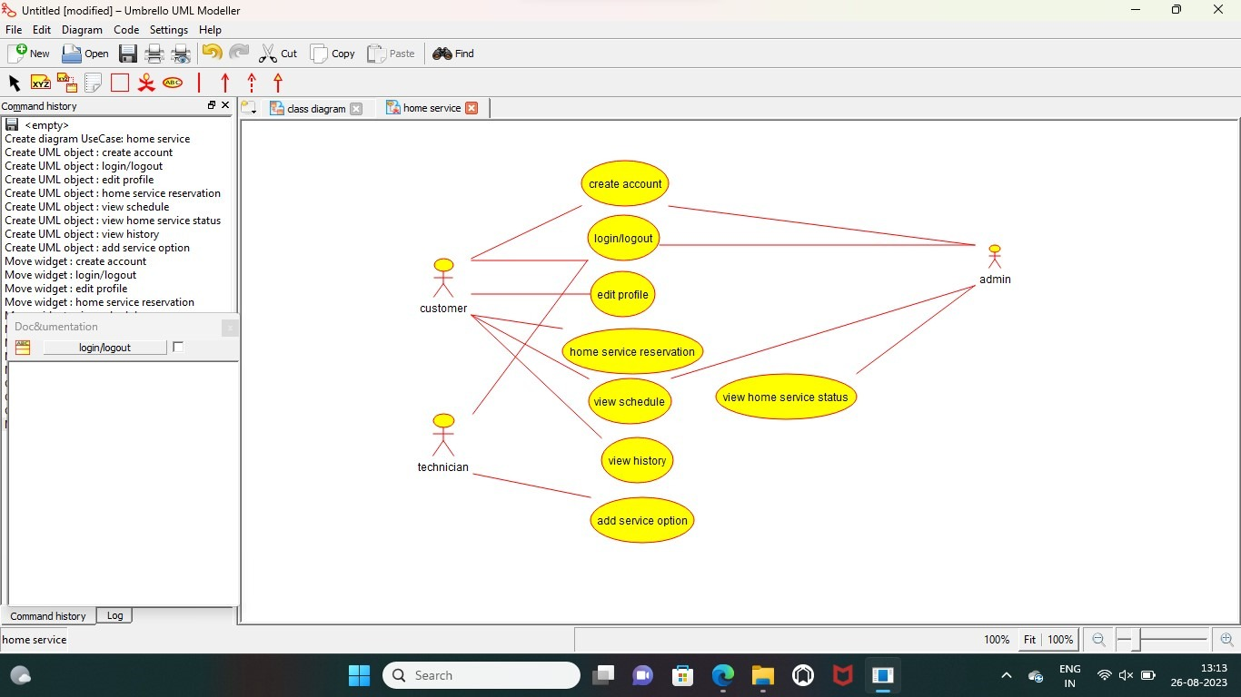

**COMPONENT:**

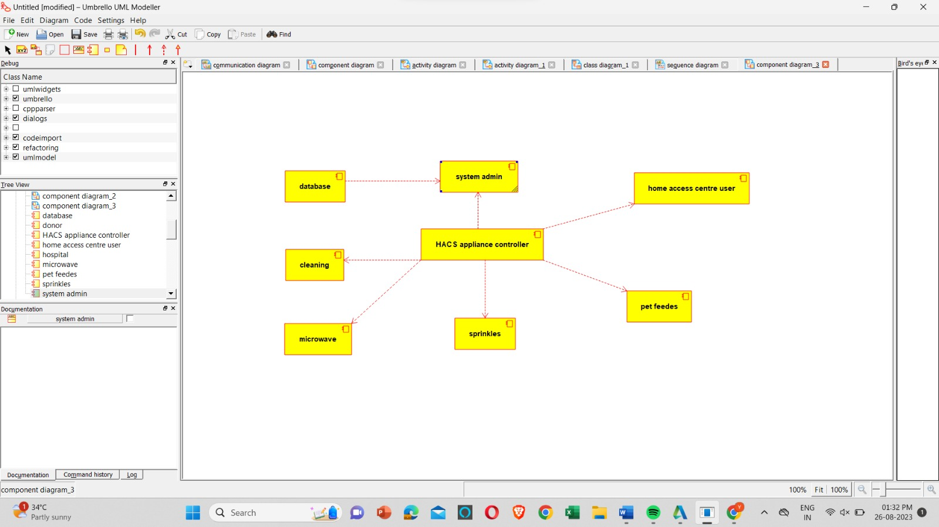

**DEPLOYMENT:**

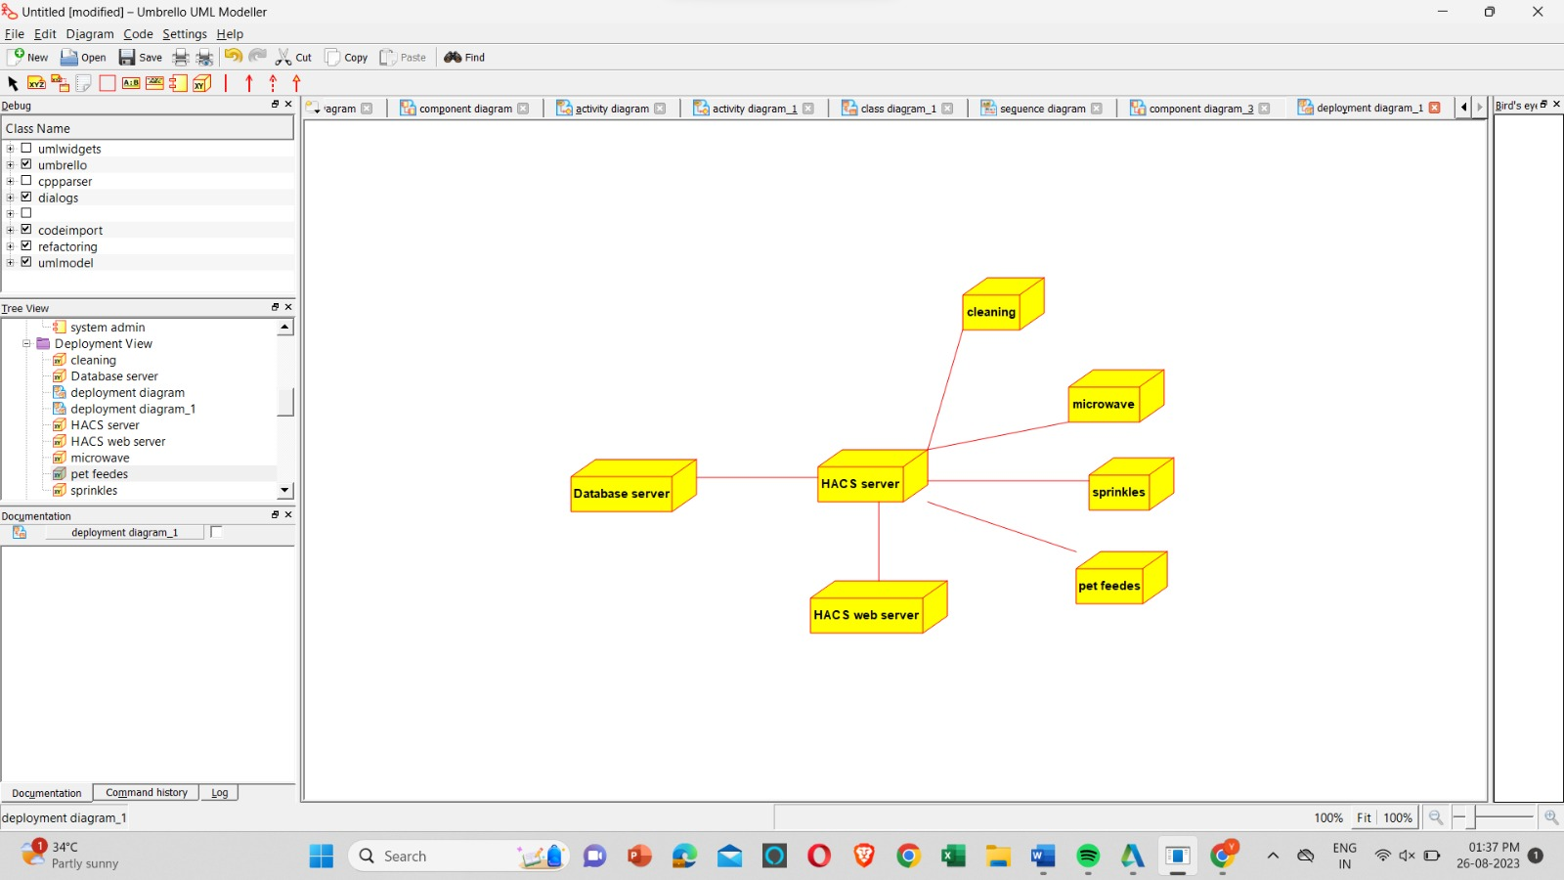

**RESULT :** Program was Executed Successfully using Umbrello.

**EXP 20:LIBRARY MANAGEMENT SYSTEM**

**AIM :** To draw the UML diagrams for food ordering system using umbrello.

**COMPONENT:**

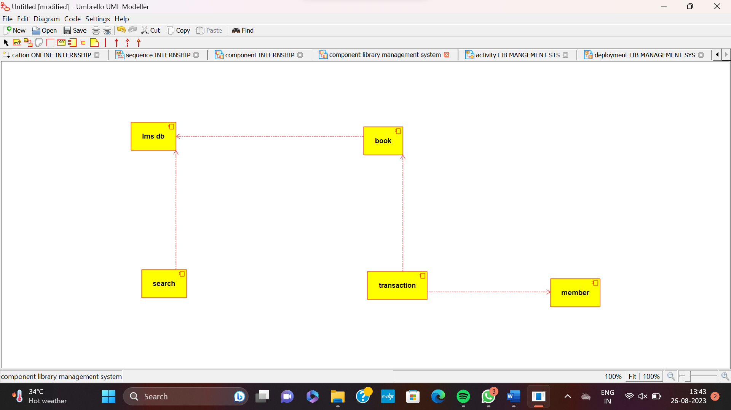

**ACTIVITY DIAGRAM:**

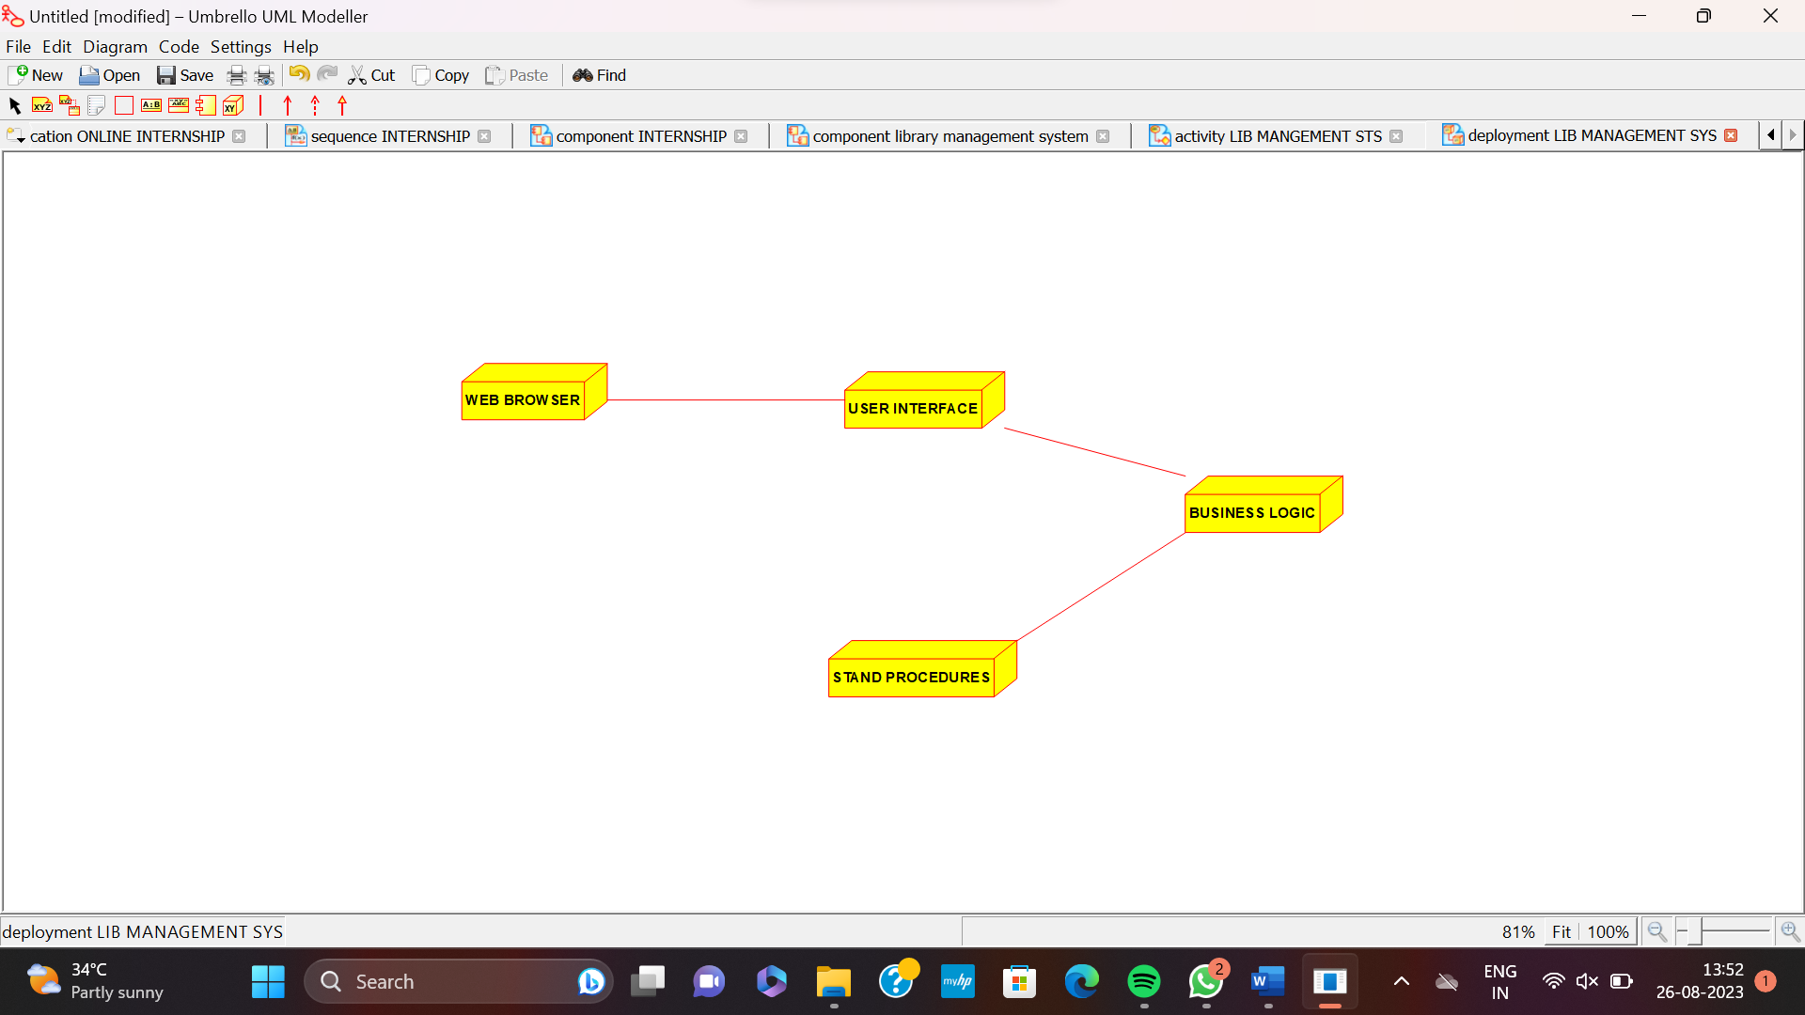

**ACTIVITY DIAGRAM:**

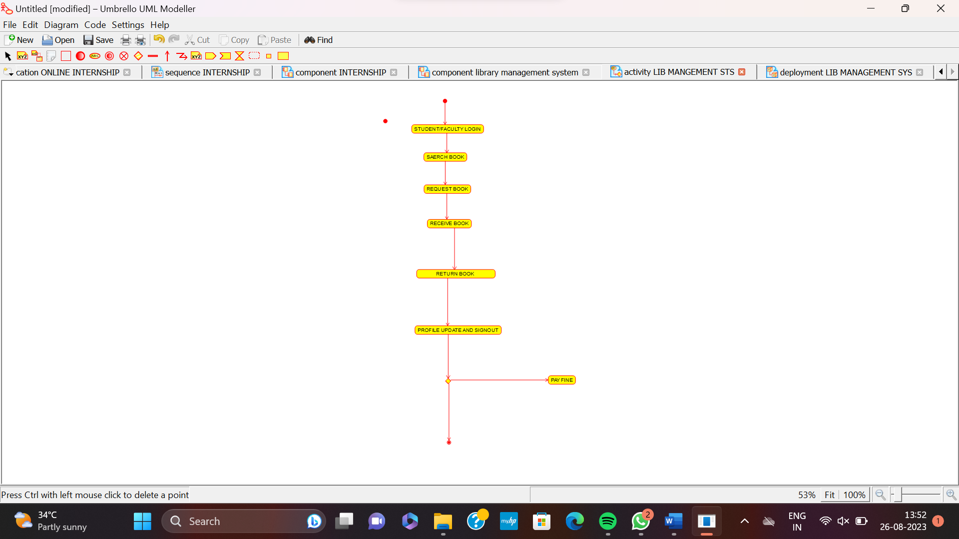

**DEPLOYMENT DIAGRAM:**



**RESULT :** Program was Executed Successfully using Umbrello.